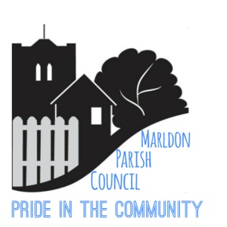 MARLDON PARISH COUNCIL
PARISH COUNCIL EXTRAORDINARY MEETING
MONDAY 21st JUNE 2021 @ 7.15pm
This meeting will be held in St John The Baptist Church, Marldon
FULL SOCIAL DISTANCING AND COVID REQUIREMENTS
Please see our webpage for further information and any changes due to any new restrictions imposed by Government.
Anyone entering the meeting without a face-covering will not be permitted access (unless medically exempt – proof required). Names, addresses and telephone numbers will be required. You will also be asked relevant questions regarding your health i.e temperature, vaccine proof, etc.
It is requested that numbers are kept to a minimum purely so as to reduce any risk of spreading the COVID virus. If you have a question which needs a response, then please email as per our protocol below.
Dear Councillors,
You are hereby summoned to attend a Meeting of Marldon Parish Council on MONDAY 21ST JUNE 2021 @ 7.15pm – Councillors ONLY – Please ensure you bring your own pens and print off copies of the Agenda and previous minutes for your own use.

Please note under the Openness of Local Government Bodies Regulations 2014 this meeting has been advertised as a Public Meeting as such could be filmed or recorded by broadcasters, the media or members of the public. Anyone wishing to record or film must obtain prior consent and make themselves known prior to the start of the meeting.

PUBLIC FORUM 7.15pm to 7.30pm
PROTOCOL - QUESTIONS TO BE RECEIVED BY THE CLERK NO LATER THAN
5pm on Thursday 17th June 2021 – no questions will be taken from the floor.
Chairman will give a short In Memoriam for Cllr. Palk.
1. Apologies:
2. Declaration of Interest
3. Approval of the Minutes of the Parish Council meeting held on 4th May 2021
4. Approval of the Annual Accounts by the full Council and signing off. Signing of the Governance Statement by the Chairman and Clerk.
5. Selection of new Councillor: Paper Vote to take place.
6. Delegation Authorisation – Personnel Committee : Chairman (Documents circulated prior to meeting)

7. Planning Applications received:
Ref: 1711/21/FUL – Removal of four existing barns and replacement with three new dwellings
Ref: 1304/21/ARM - Application for approval of reserved matters following outline approval 34/1890/15/O

8. Date of Next Meeting: MONDAY 14th JULY 2021 – VENUE to be confirmed.

Susie Watt
Parish Clerk (the Proper Officer) & Responsible Financial Officer
Date: 15th June 2021

