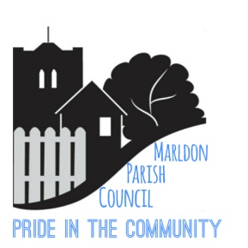 MARLDON PARISH COUNCIL
PARISH COUNCIL
TUESDAY 18th January 2022 @ 7.45pm
This meeting will be held in the Main Hall, Marldon Village Hall
IMPORTANT NOTICE – PROOF OF A NEGATIVE LATERAL FLOW TEST TAKEN BEFORE THE MEETING WILL BE REQUIRED PRIOR TO ENTRY
FULL SOCIAL DISTANCING AND FACE COVERINGS REQUIRED

Anyone entering the meeting without a face-covering will not be permitted access (unless medically exempt – proof required). It is requested that numbers are kept to a minimum purely so as to reduce any risk of spreading the COVID virus. SEE ABOVE
If you have a question which needs a response, then please email as per our protocol below.
Dear Councillors,
You are hereby summoned to attend a Meeting of Marldon Parish Council on Tuesday18th January 2022 @ 7.45pm – Councillors ONLY – Please ensure you bring your own pens and print off copies of the Agenda and previous minutes for your own use.

Please note under the Openness of Local Government Bodies Regulations 2014 this meeting has been advertised as a Public Meeting as such could be filmed or recorded by broadcasters, the media or members of the public. Anyone wishing to record or film must obtain prior consent and make themselves known prior to the start of the meeting.

PUBLIC FORUM 7.45pm to 8pm
PROTOCOL - QUESTIONS TO BE RECEIVED BY THE CLERK NO LATER THAN 5pm on Friday 14th January 2022 – one question per resident only and relevant to the Agenda. Maximum 6 questions.
Members of the Public are reminded that a Parish Council Meeting is not a public meeting and to respect that Council Business must be conducted without interruption.
1. Apologies:
2. Declarations of Interest:
3. Approval of the Minutes of the Parish Council meeting held on 6th January 2022
4. Clerk’s Report/Finance Update. General update. Finance report (circulated prior).
5. Events Team Update: Cllr. Taylor – 2022 Events.
6. Nomination & Vote for Parish Council Representative on Village Hall Committee:
7. Nomination & Vote for Roads and Road Safety Officer:
8. FOI & ICO Complaints Procedure Update: Discussion and vote to publicise all FOI & ICO complaints to ensure the Community is aware of potential problems being created in areas within the Parish. (The Proper Officer)

Date of Next Meeting: The Parish Council Meetings will now be the 3rd Tuesday of the Month (subject to change) therefore, the next full Parish Council meeting will be Tuesday 18th February 2022 in the Main Hall, Marldon Village Hall at 7.45pm (tbc)

Susie Watt
Parish Clerk (the Proper Officer) & Responsible Financial Officer
Date: 10th January 2022

